**MUHAMMAD NAZREN BIN ISHAK**

* I am using the MySQL Database.

Section A

Answer Question 1

* First I create a Database name `Enoquix`
* Second I drop the exist table and create new table name `user` and `user_singin_logs`

DROP TABLE IF EXISTS `users`;

CREATE TABLE IF NOT EXISTS `users` (

`user_id` int(11) NOT NULL AUTO_INCREMENT,

`email_id` varchar(200) NOT NULL,

`password` varchar(64) NOT NULL,

`first_name` varchar(128) NOT NULL,

`last_name` varchar(128) NOT NULL,

`enabled` bit(1) DEFAULT NULL,

PRIMARY KEY (`user_id`)

);

DROP TABLE IF EXISTS `user_singin_logs`;

CREATE TABLE IF NOT EXISTS `user_singin_logs`(

`user_id` int(11) NOT NULL,

`session_id` varchar(128) NOT NULL,

`signed_in_time` timestamp NOT NULL,

`signed_out_time` timestamp NOT NULL,

PRIMARY KEY (`session_id`),

FOREIGN KEY (`user_id`) REFERENCES users (`user_id`)

);

Answer Question 2

=>To answer question 2, I have insert a few data base on both table

=>The FULL JOIN on MYSQL is not supported. Thus, I am using this structure to emulated them based on

question given

=> This join query will fetch user_id, signed_in_time, signed_out_time by descending order.

SELECT users.user_id,user_singin_logs.signed_in_time,user_singin_logs.signed_out_time

FROM

users LEFT OUTER JOIN user_singin_logs

ON users.user_id = user_singin_logs.user_id

UNION

SELECT users.user_id,user_singin_logs.signed_in_time,user_singin_logs.signed_out_time

FROM

users RIGHT OUTER JOIN user_singin_logs

ON users.user_id = user_singin_logs.user_id

ORDER BY user_id DESC;

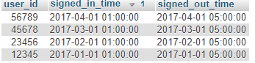

Answer Question 3

=>Based on the question, let’s say there’s no primary key in users table

=>Assume I dropping the primary key using following command:

ALTER TABLE users

DROP PRIMARY KEY;

=>Then to answer the question, I executed the following command:

SELECT SUM(user_id)

AS NumUniqueUser

FROM (

SELECT COUNT(DISTINCT user_id) AS user_id

FROM users

UNION

SELECT COUNT(DISTINCT user_id) AS user_id

FROM user_singin_logs

) AS u;



Answer Question 4

=>Based on the question, let’s say there’s no primary key in users table

=>To answer the given question, I executed the following command:

SELECT user_id,COUNT(*) AS Num_Duplicate_Existed FROM

(

SELECT user_id FROM users

UNION ALL

SELECT user_id FROM user_singin_logs

)AS Num_UniqueUser

GROUP BY user_id

HAVING COUNT(*)>1;

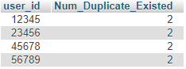

Section B

Question 1

=>Based on the question, the output for the following program is:

=> Output: 72 7 34 foo34 7foo

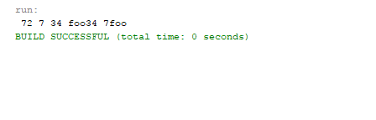

Question 2

=>Please refer to the jar. file